# Problem Set 5 - Shikhar Bakhda

## UNI: ssb2189

Question 5

To transmit this image in exactly 0.01 seconds,

Question 11a

The smallest number of links would be if all the nodes were arranged in a straight line and connected. When this is done, every node has 1 link except the first node which has 0 links. Thus the minimum number of links is a WAN with N nodes,

Question 11b

* I think that a **star** topology is the most reliable interconnection network.
* This is because in a star topology, for *any* N links getting spoilt *only* N computers are disconnected and the rest of the computers will function as usual.
* The minimum number of links required for a star topology is
* In the bus topology, if the bus is spoilt, all computers are disconnected, so it is unreliable.
* In a ring topology, if 2 non-adjacent links are spoilt, more than 2 computers are disconnected.

Question 16a

1. A 🡪 B 🡪 C 🡪 G
2. A 🡪 B 🡪 E 🡪 C 🡪 G
3. A 🡪 B 🡪 E 🡪 D 🡪 C 🡪 G
4. A 🡪 D 🡪 C 🡪 G
5. A 🡪 D 🡪 E 🡪 C 🡪 G
6. A 🡪 D 🡪 E 🡪 B 🡪 C 🡪 G
7. A 🡪 F 🡪 G

Question 16b

Using the Dijkstra’s algorithm, we get the following table:

|  |  |  |  |  |  |  |  |
| --- | --- | --- | --- | --- | --- | --- | --- |
| A | 0A | X | X | X | X | X | X |
| B |  | 5A | 5A | X | X | X | X |
| C |  |  |  | 9B | 9D | 8E | X |
| D |  | 6A | 6A | 6A | X | X | X |
| E |  |  |  | 7B | 7D | X | X |
| F |  | 3A | X | X | X | X | X |
| G |  |  | 11F | 11F | 11F | 11F | 10C |

* We started at A.
* A could see B, D, and F, and the smallest path among B, D, and F was F
* F could see G, and the smallest path among B, D and G was B
* B could see C and E, and the smallest path among C, D, E, and G was D
* We now had some information on all paths, so there were no infinities
* From D the smallest path among C, E and G was E
* From E the smallest path between C and G was C
* From C the last remaining path was now G
* Thus we end at G

Tracing backwards, we get the path:

**A 🡪 D 🡪 E 🡪 C 🡪 G**

We also get a second shortest path if we take 7B instead of 7D:

**A 🡪 B 🡪 E 🡪 C 🡪 G**

**The shortest paths are**

1. **A → D → E → C → G**
2. **A → B → E → C → G**

**With a delay of 10 for each.**

Question 16c

|  |  |  |  |  |  |  |
| --- | --- | --- | --- | --- | --- | --- |
| A | 0A | X | X | X | X | X |
| B |  | 5A | 5A | X | X | X |
| C |  |  |  | 9B | 9D | X |
| D |  | 6A | 6A | 6A | X | X |
| F |  | 3A | X | X | X | X |
| G |  |  | 11F | 11F | 11C | 11C |

Let us now perform Dijkstra’s algorithm but without E.

We started at A.

A could see B, D, and F, and the smallest path among B, D, and F was F

F could see G, and the smallest path among B, D and G was B

B could see C, and the smallest path among C, D, and G was D

We now had some information on all paths, so there were no infinities

From D the smallest path between C and G was C

From C the last remaining path was now G

Thus we end at G

Tracing backwards, we get the shortest path of 11:

**A 🡪 D 🡪 C 🡪 G**

We also get a second shortest path of 11 if we take 9B instead of 9D:

**A 🡪 B 🡪 C 🡪 G**

We also get a third shortest path of 11 if we take 11F instead of 9C:

**A 🡪 F 🡪 G**

**Yes – if node E fails, this changes the shortest path, increasing its delay.**

**The shortest paths now are:**

1. **A → D → C → G**
2. **A → B → C → G**
3. **A → F → G**

**With a delay of 11 for each.**

Question 17

The heuristic will ***not* *always***deliver the message from node A to node B under the following 2 situations:

1. Node A and Node B lie in disconnected networks, as shown in Fig. A.
2. Let ring network X be defined as follows:
   1. Let’s say there’s a ring network X connected to the main network. X does not contain node B.
   2. Let P be a set of nodes in X that connect to the main network with one or many links.
   3. If every link of every node in P that connects to the main network is more expensive than every link of every node in P that connects to nodes in X, then a message that enters ring X will never escape. It is stuck in an infinite loop without any exits.

If a message from Node A reaches *any* node in ring X, the message will **never** reach Node B. This is diagrammatically shown in Fig. B.

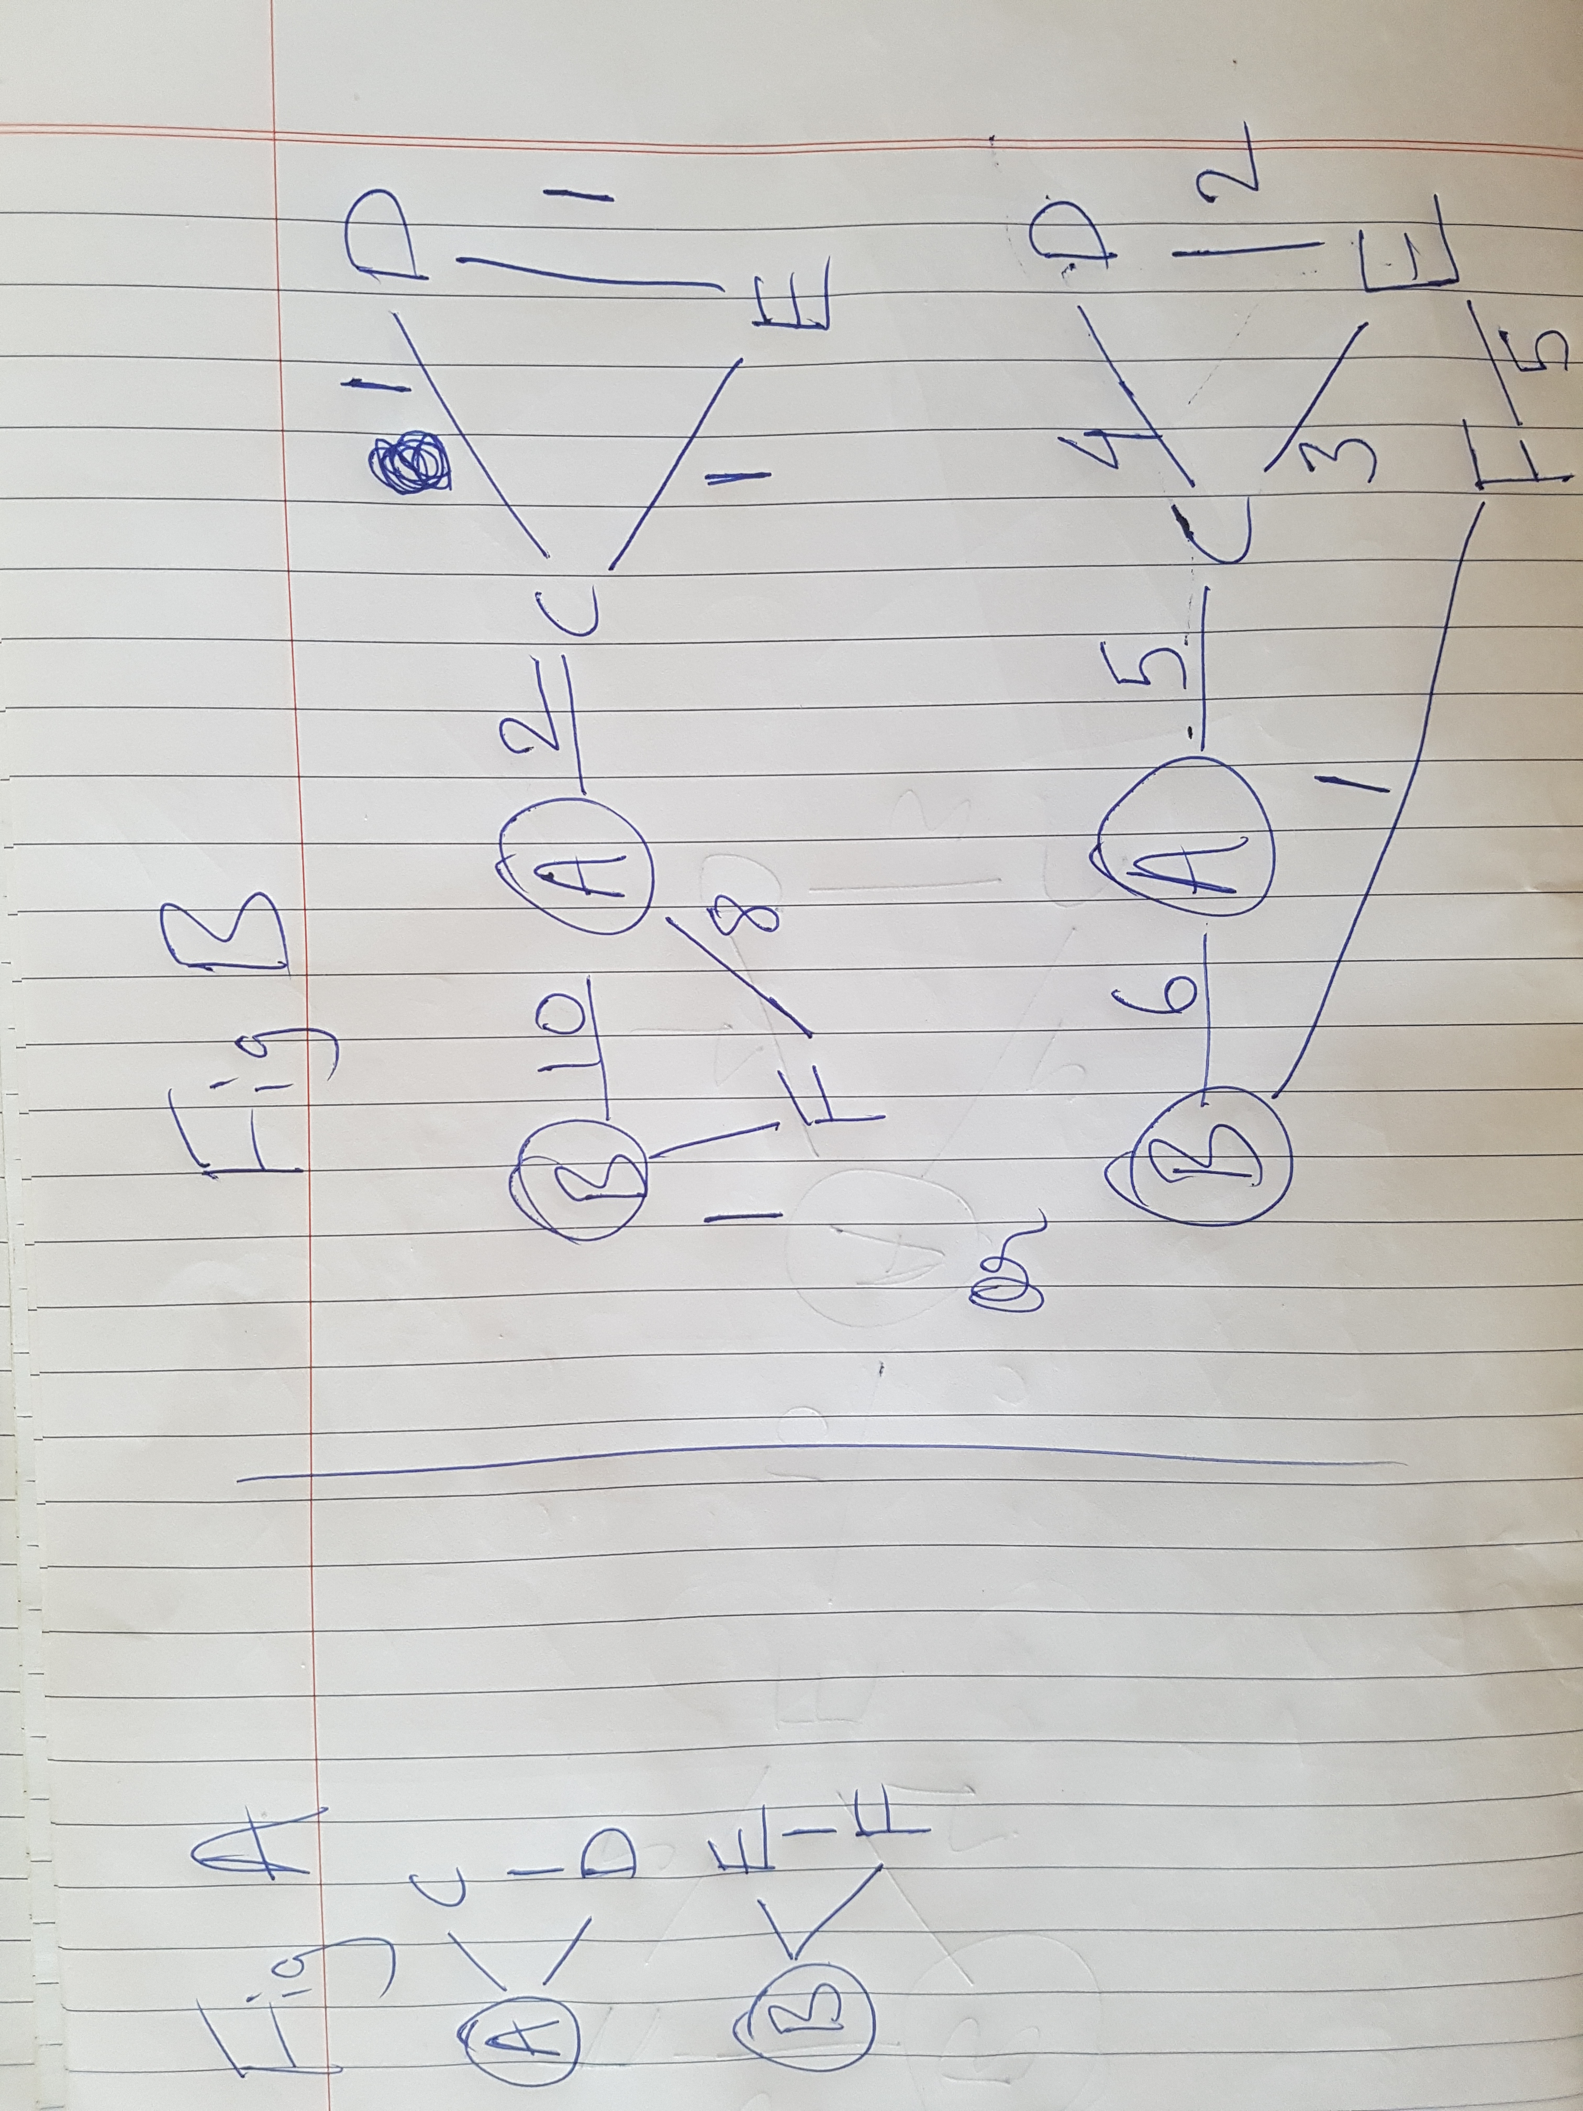

Question 20

1. **It is more reliable.**

If you’re sending a large message over the network, and if one of the nodes malfunctions during the transmission, then the whole message would not send at all. But if you’re sending the message in packets, each packet can travel independently to the destination. This means that if one node malfunctions, the packets will now take another path to the destination automatically, preventing potential data loss.

1. **It is more efficient.**

Because every packet independently choses the best possible path for itself, even if the network changes midway during transmission, every path will travel the shortest possible path. If we sent one big message it would continue using the longer path even if a shorter path opened up midway.

1. **It is more secure.**

If there is a network breach in one node while the message is sent across the network, the evil person *might* not get the whole message since packets *can* travel through different routes. If a long message was sent he will *certainly* get the whole thing.

1. **It can fix data loss more easily.**

If you were to send a large message and there was data loss in the message, the whole thing will be have to be sent again, increasing the volume of data travelling through the network. In the case of packets, only the corrupt packets will have to be sent again, which have a much smaller total volume.

**Question 21 is on the next page**

Question 21

Vinton Serf, or the “Father of the Internet” as he is called, is widely acclaimed for his contribution to the development of the Internet. He created the TCP/IP protocols used widely today by many appliances. As vice president of MCI Digital Information Services from 1982-1986, Serf coded the first commercial email service to be connected to the Internet, called MCI Mail. In his life Vinton has led teams of computer scientists and computer engineers, who, in his leadership created the backbone of the internet as we know it, from advanced Internet frameworks for delivering combinations of data, information, voice and video services, which were widely used by private consumers and businesses alike.

For his work on developing the fundamental architecture of the internet, he was awarded the prestigious US National Medal of Technology by then President Clinton in 1997. However, this was not his first national honor. He also served in the US Department of Defense for his nation by fashioning network structures based on data packets, which were more efficient, secure, reliable and cheaper than sending huge chunks of messages across military bases. After 12 long years of service in the US Department of Defense, he is now the chairman of board of the Internet Corporation for Assigned Names and Numbers (ICANN), which helps organize the internet for a large population.

Serf also had goals with far sighted visions for the world. To make the Internet more accessible to places other than big cities, he founded the Internet Societal Task Force that analyses international, national and local policies surrounding Internet use. To raise awareness about the new internet protocol, and informing businesses how to raise speeds, he founded the IPv6 Forum.

In December, 1994, People magazine identified Cerf as one of that year's "25 Most Intriguing People." Cerf is very highly knowledgeable and holds a Bachelor of Science degree in Mathematics from Stanford University and Master of Science and Ph.D. degrees in Computer Science from UCLA. He also holds honorary Doctorate degrees from 8 other universities. He has effectively used his knowledge to very well deserve the title “Father of the Internet” and all his other accolades. We should thank him every time we open up for web browser, as his initiatives and contributions and inventions have made a tiny network in CERN a platform of billions of users that can now communicate near the speed of light. He then also helped us harness this overwhelming power of the internet by developing the necessary protocols.

Yes, he just had one lifetime. And we do too.